**Installation Documentation for Inbox Analysis Tool**

Step 1:

Save the accompanying text file and open it, as it will be needed for Step 4. The text file contains the Visual Basic script that will be added to the user’s instance of Outlook 2010.

Step 2:

Inside Outlook 2010, press Alt + F11 to open up the Visual Basic Editor.

If prompted with a security notice, click “Enable Macros”.

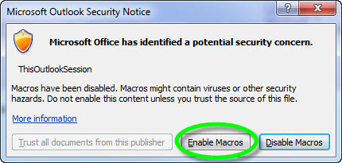

Step 3:

Inside the Visual Basic Editor, expand the folders under Project until you find ThisOutlookSession, and double-click it to open it.

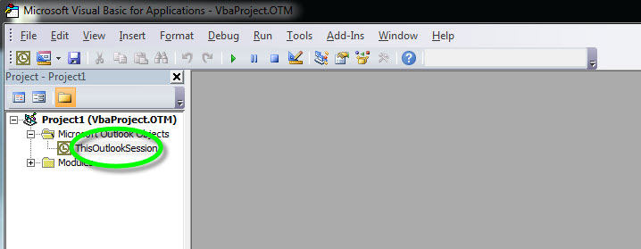

Step 4:

Paste the script downloaded from Step 1 into the right side of the screen.

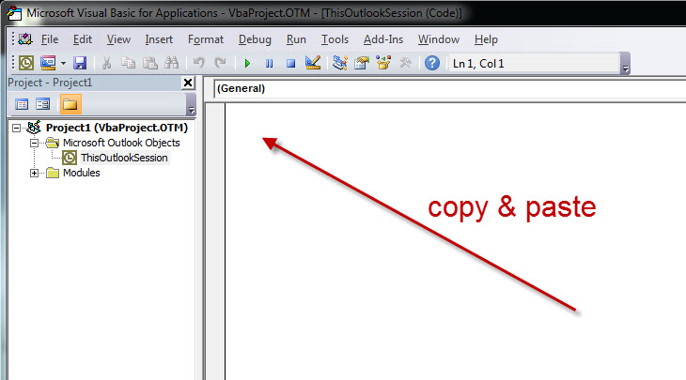

Step 5:

To create a button for the script, first go to File > Options > Customize Ribbon.

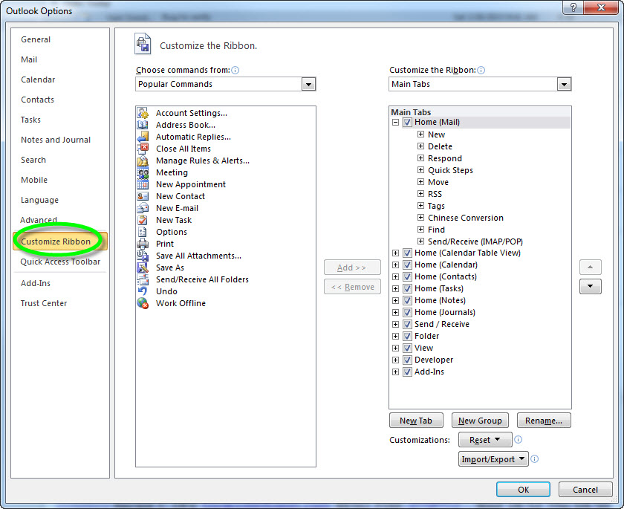

Step 6:

Select the Home tab and click New Group.

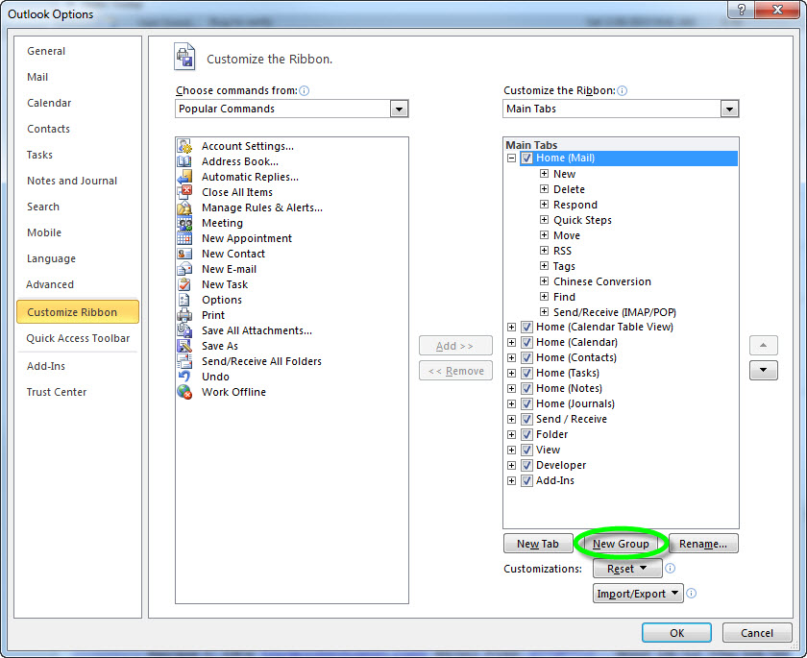

Step 7:

To rename the New Group, click Rename.

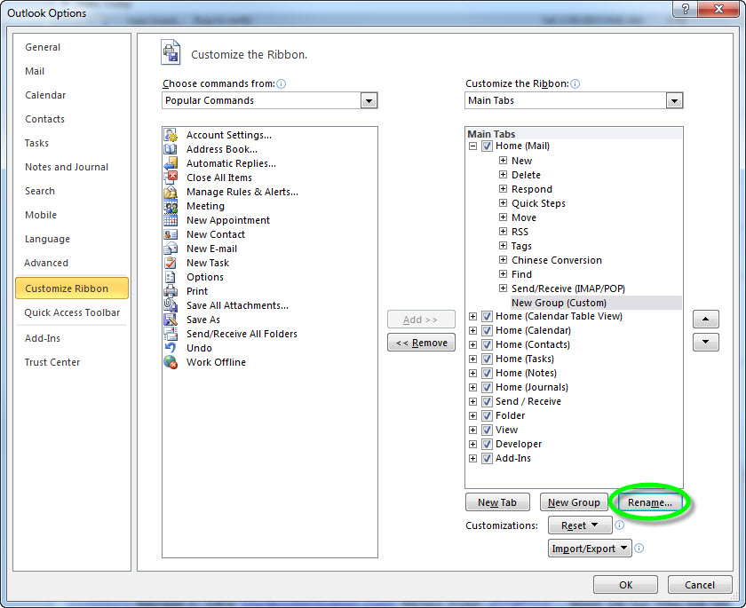

Step 8:

Rename the group “Inbox Analysis Tool” and select the first icon. Click OK.

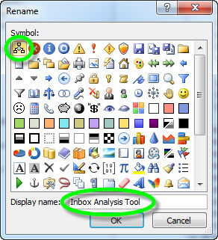

Step 9:

Under “Choose commands from:”, select Macros. Select the only item in the list and click Add >>.

Click OK.

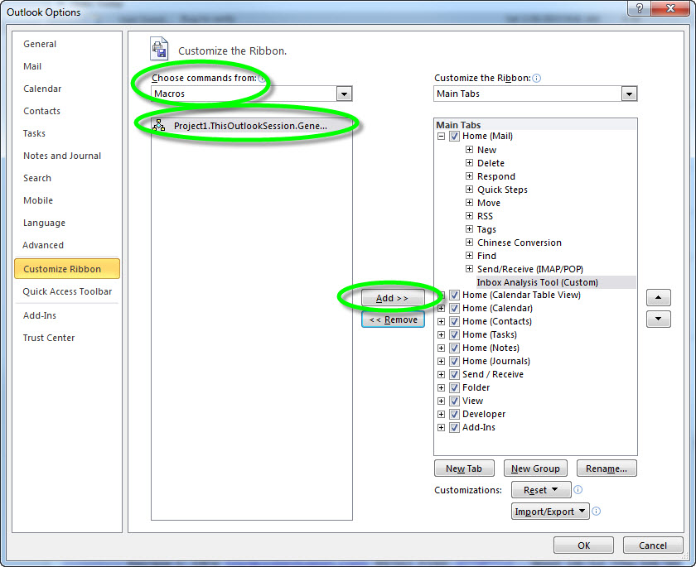

Step 10:

Users will now see the new button on their home tab in Outlook 2010.

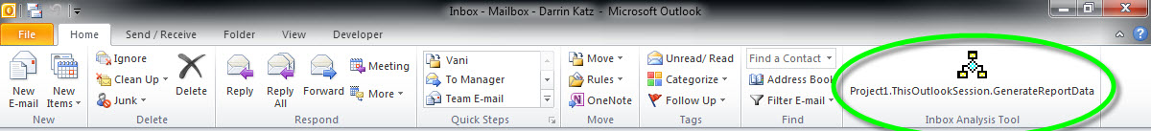

Step 11:

It is crucial that Outlook 2010 is now closed in order for this prompt to appear. Click “Yes”.

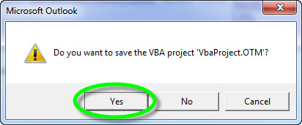

Step 12:

Re-open Outlook 2010. Users must be instructed to click the new button at least once a day during the reporting period.